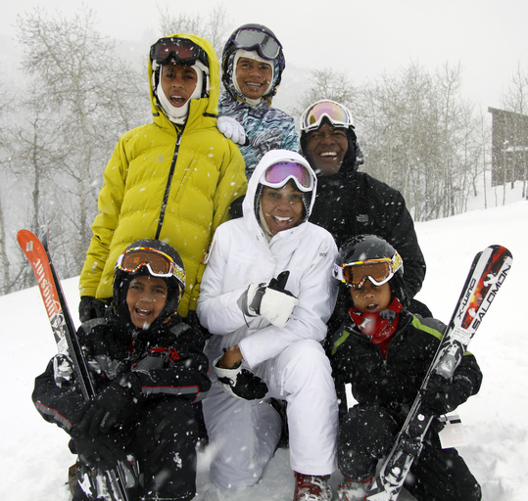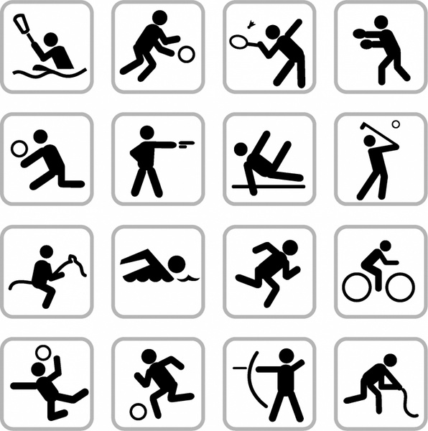

CT Soul Ski and Sports Club's mission statement is to have fun, while promoting outdoor activities. We believe in providing opportunities for individuals, families, groups and community members to enjoy education and growth in recreational activities.

We are committed to diversity, equity and inclusion.

Contact us at ctsoul01@gmail.com [Ctsoul01@gmail.com](mailto:Ctsoul01@gmail.com)

Call:----------

aA

Membership is yearly from May to May

Our Club Meets :2nd Wednesday each Month in Hamden or Via Zoom

https://us02web.zoom.us/j/2366508551?pwd=NjNDTnpRSkRYSFhibmFSSHk4L0thQT09

Meeting ID: 236 650 8551

Passcode: 1prdoT

**Membership & Fees**

Adult: $50 Family of 4: $90

Couples: $70 Senior (65+):$35

Adult & Child:$60

Youth/Student with ID: $35.00

Applications can be found on our website: www.ctsoul.biz

CT Soul Ski and Sports Club was founded in April of 2021 in Hamden, Connecticut. We are a member of the National Brotherhood of Skiers ( NBS) and the Connecticut Ski Council ( CSC). CT Soul Ski and Sports Club members participate in skiing, snowboarding, and other winter sports. We are committed to activities for all four seasons, whether it be: hiking, fishing, kayaking, swimming, golf or club parties and cookouts

### CT Soul Ski and Sports Club, Inc

### 2514 Whitney Ave

### #185083

### Hamden, Ct 06518

### Website: www.ctsoul.biz

### a

## Our Club’s Motto: LIVE LIFE 2 ITS FULLEST

Why Join A Club

* Meet New People
* Learn New Skills
* Improve Confidence
* Increase Knowledge
* Fitness
* Develop New Friendships
* Networking

“Your kids will remember the adventures you went on, not the stuff you brought them. Kids outgrow stuff, they never outgrow adventures. Every child needs nature. Not only those of a certain economic class or culture or set of abilities. Every child” *Richard Louv*

**“You were wild once here. Don’t let them tame you”**

**Isadora Duncan**

1. It Boosts Immunity
2. It Reduces the Risk of Depression
3. It Improves Memory and Focus
4. It Can Help Speed the Healing Process
5. It Curbs Stress
6. It Eases Aggression
7. It Strengthens Family Bonding
8. It Helps with Sleep

*By: Livestrong.com*

# 8 Compelling Reasons to Spend More time Outdoors

CT Soul Ski & Sports Club, Inc